
RAMAIAH
INSTITUTE OF TECHNOLOGY
USN | 1 | M | S

(Autonomous Institute, Affiliated to VTU)
Bangalore – 560 054

SEMESTER END EXAMINATIONS – JANUARY 2017

Course & Branch | : | Electrical & Electronics Engineering. | Semester | : | VII
Subject | : | Power Systems - II | Max. Marks | : | 100
Subject Code | : | EE702 | Duration | : | 3 Hrs

Instructions to the Candidates:
- Answer one full question from each unit.

 |  |  | UNIT – I
1. | a) |  | Explain the following with examples (i) Tree (ii) Co-tree (iii) Oriented graph iv) Primitive Network v) primitive element | CO1 | (05)
 | b) |  | Evaluate an expression for Y_{bus} using singular transformation method. | CO1 | (07)
 | c) |  | For the network shown in Fig 1.c, Form bus impedance matrix by building Algorithm  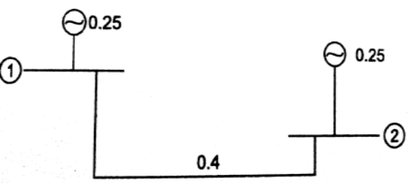  Fig 1.c | CO1 | (08)
2 | a) |  | Determine the bus admittance matrix by singular transformation analysis for the power system defined by the line data shown below in the table 2a. 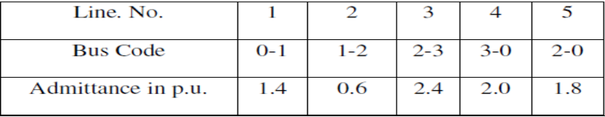  Table 2a | CO1 | (06)
 | b) |  | Evaluate the general expression for Z_{bus} building algorithm without mutual coupling when a branch is added between the two existing buses to the partial network. | CO1 | (08)
 | c) |  | Form A, B and C incidence matrices for the given graph in Fig 2c. Assume elements 3, 5 as links  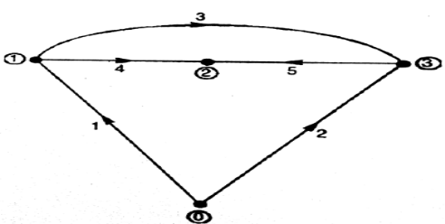  Fig 2c | CO1 | (06)
 |  |  | UNIT – II
3. | a) |  | Categorize the buses required to carry out the load flow analysis in a power system. What is the significance of a slack bus. | CO2 | (05)
 | b) |  | Write an algorithm for Newton Raphson method of load flow analysis for a power system having PQ and PV buses | CO2 | (08)
 | c) |  | For the network shown in fig 3c, determine the complex voltage at bus-2 at the end of first iteration. Line impedances are marked in p.u. Given that bus-1 is a slack bus with V1= 1+j0 p.u, P2 + jQ2 = -5.96 + j 1.46 p.u and |V3| = 1.02 p.u. Use Gauss – Seidel method.  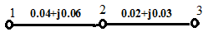  Fig 3c | CO2 | (07)
4. | a) |  | Differentiate the load flow analysis between Gauss siedel and Newton raphson methods with respect to the following.  (i)Time per iteration & Total computation time (ii) Number of iterations (iii) Acceleration factor (iv) computer memory storage (v) Convergence characteristics. | CO2 | (05)
 | b) |  | Develop the Gauss-seidel load flow model for a power system having a slack bus and (n-1) number of PQ buses. Illustrate with an algorithm. | CO2 | (10)
 | c) |  | List the the assumptions made in Fast Decoupled Load Flow method of analysis. | CO2 | (05)
 |  |  | UNIT – III
5. | a) |  | Explain the relationship between transmission loss & loss coefficients in a two bus power system | CO3 | (10)
 | b) |  | Determine the minimum cost of generation per day for the load curve shown in Fig. 5b. The fuel input in calories per hour for plant1 and plant 2 are given as.  The minimum and maximum loads on the units are 10MW and 100MW.Take cost of fuel as Rs 10 / Million Calorie  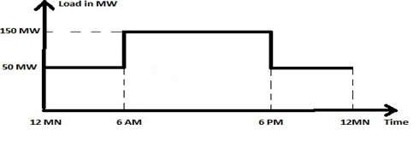  Fig 5b | CO3 | (10)
6. | a) |  | Write brief note on unit commitment along with the problem formulation | CO3 | (06)
 | b) |  | Derive an expression for penalty factor for optimal economic dispatch including losses | CO3 | (06)
 | c) |  | Calculate the required generation for each plant and power received by load when the system λ is Rs. 25/MWh. If the 100MW is transmitted from plant 1 to load with a transmission loss of 10MW as shown in Fig 6c. Given the incremental fuel costs of two plants as dC₁/dP_{G1}=0.02P_{G1}+16 ; dC₂/dP_{G2}=0.04P_{G2}+20  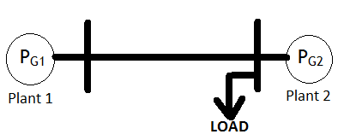  Fig 6c | CO3 | (08)
 |  |  | UNIT – IV
7. | a) |  | Explain the solution of swing equation using Modified Euler’s method in stability analysis. | CO4 | (10)
 | b) |  | Illustrate the solution of swing equation by point by point method. | CO4 | (10)
8. | a) |  | Discuss the method of transient stability of a given power system based on Runge kutta method. | CO4 | (10)
 | b) |  | Discuss the transient stability studies in representing synchronous machine and load. | CO4 | (10)
 |  |  | UNIT – V
9. |  | a) | Explain with a neat sketch the speed governing system of single area automatic load frequency control. | CO5 | (10)
 |  | b) | Discuss ALFC and AVR loops of synchronous machine with a neat block diagram. | CO5 | (10)
10. |  |  | Write brief note on:  - Load Compensation  - Line Compensation  - Series Compensation  - FACTS Controllers. | CO5 | (20)

****************

